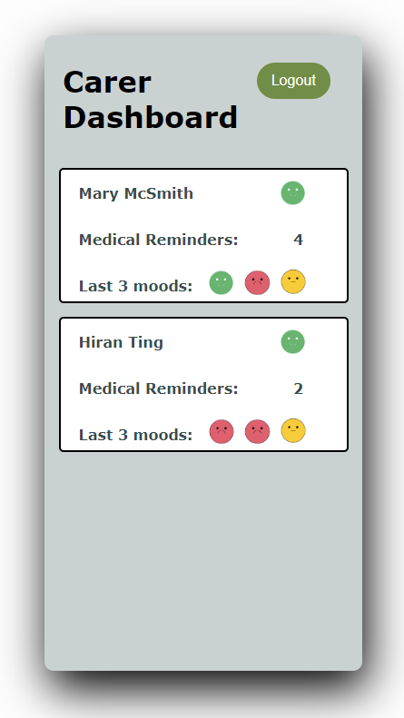

You would Click on this

And it would show a more in-depth overview like this :
NAME: Hiran ting
Age: 67
Diagnosis: heart disease
Symptoms: chest pain, shortness of breath, coughing or wheezing
Next appointment: 20th may 2024
Mood: (picture of recent moods)
Current medication: beta blocker changed from antiplatelet drug

Overview
After assessing Patient’s mood, we found out that his dejected mood was directly correlated to the antiplatelet drug. the symptoms where stomach pain and indigestion so we have changed him to a beta blockers to nullify these symptoms we shall check up with the patient in 2-3 weeks to see if the symptoms have improved.

